
SHUTE UNIVERSITY
樹德科技大學
824高雄市燕巢區橫山路59號

Department of Information Management

“Artificial Intelligence in Gaming: Enhancing the Player Experience”


About The Author
Zircon Jade Casimero (陳子傑), born on November 6, 2004, in the Philippines, is the eldest of six siblings and hails from Poro, Camotes, Cebu. Growing up in a close-knit family instilled in him strong values of leadership, discipline, and compassion. Zircon has always strived to be a positive role model for his younger siblings S24101314@stu.edu.tw
believing that determination and perseverance pave the way to success. As a dedicated and curious learner, Zircon’s passion for discovery led him to pursue his studies abroad as an international student scholar at Shute University. Deeply fascinated by technology and innovation, he has developed a particular interest in Artificial Intelligence (AI) and its transformative role in shaping modern life. His article, “Artificial Intelligence in Gaming: Enhancing the Player Experience,” reflects his enthusiasm for exploring how AI revolutionizes interactive entertainment by creating smarter, more immersive, and engaging gaming experiences.
Abstract
Artificial Intelligence (AI) has become an essential element in the development of modern video games. It enhances the overall player experience by allowing games to think, learn, and respond intelligently to player actions. AI helps create realistic characters, adaptive challenges, and immersive environments that keep players engaged. This article discusses the role of AI in gaming, its different functions and applications, and how it transforms the way players interact with virtual worlds. Through these innovations, AI continues to shape the future of the gaming industry by making games more dynamic, enjoyable, and lifelike.

Introduction
Artificial Intelligence (AI) has become a major force in shaping the gaming industry. It allows games to go beyond fixed rules and predictable actions, creating experiences that feel more dynamic and realistic. Through AI, game characters can think, react, and adapt to the player’s behavior, making gameplay more interactive and personalized.
AI is now widely used in video games to enhance player engagement and immersion. From smart enemies that learn from player strategies to environments that change based on decisions, AI brings games to life in new and exciting ways. Developers use AI to design systems that challenge players, simulate real-life situations, and create endless possibilities within a game.
This article explores how Artificial Intelligence works in gaming, its applications, and its impact on the overall player experience. It also discusses how AI continues to evolve, shaping the future of digital entertainment and offering players a richer and more intelligent form of play.

Content
Artificial Intelligence (AI) in video games is the use of AI techniques to control non-player characters (NPCs), adapt to player actions, and create dynamic game environments. These AI systems can include pathfinding, decision-making, and real-time adaptations to improve gameplay and challenge. The goal is to make games more immersive by enabling characters to act intelligently and respond to the player’s actions in a natural way.

Definition
I in gaming refers to the technology that makes non-player characters (NPCs) and game environments react intelligently to player actions. Instead of following fixed patterns, AI allows these characters and environments to learn and adapt, creating a more realistic and unpredictable experience. AI in games can control enemy behavior, adjust difficulty levels, and even generate new content to keep the game fresh and engaging for players. In simpler terms, it makes the game feel like it’s alive, constantly responding and evolving with the player.

Preface
Games today are not just about playing through levels or missions. AI has made gaming more dynamic by creating smarter characters and environments that react to player actions. In this article, we’ll look at how AI is used in gaming, how it makes games more interesting, and the challenges it creates for developers. AI is shaping the future of gaming by giving players a more personalized and interactive experience.

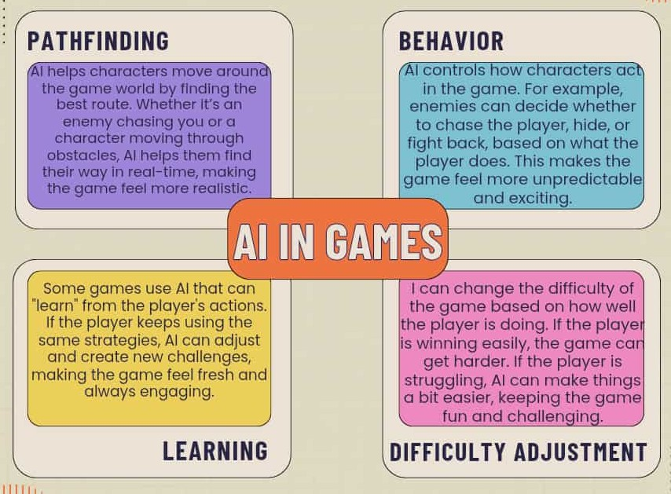
Theoretical Framework
Artificial Intelligence in gaming is based on several key concepts and techniques that allow game characters, environments, and systems to behave in smart and interactive ways. The main areas where AI is used in gaming include:

Practical / Hands-On Exercise
Artificial Intelligence (AI) is easier to understand when experienced through real activities, especially in gaming. By interacting with AI in popular games, we can see how it makes gameplay more dynamic, realistic, and challenging. The following exercises show how AI works, adapts, and responds to player actions
1. Playing Against AI in Games
In games like Chess, Mobile Legends, Call of Duty, players compete against AI-controlled opponents. These AI opponents can learn and adapt based on the player’s actions. For example, if you keep using the same strategy in Chess, the AI may start defending against it in the next moves. Observing these changes helps players see how AI enhances competition and creates more realistic gameplay.
Learning outcome: Understand how AI reacts to player behavior and adapts strategies in real time.

2. Exploring Game Difficulty Settings
Games often have difficulty levels such as Easy, Normal, and Hard. Choosing a higher difficulty level changes how the AI behaves. On Hard mode, the AI may react faster, plan more advanced strategies, and provide a greater challenge. For instance, AI opponents may pass the ball more strategically and defend better on higher levels.
Learning outcome: Learn how AI adjusts responses based on the player’s skill level to ensure balanced gameplay.

3. Game Bots and Training Modes
Many games include training or practice modes with AI “bots.” These bots simulate human players and help users improve. By testing how bots respond—whether attacking, defending, or assisting—players can see how AI makes decisions in real time. For example, in Mobile Legends practice mode, bots may block attacks or follow teammates, mimicking real players.
Learning outcome: Understand how AI imitates human-like behavior and adapts continuously.

4. Creating Simple AI Using Scratch or Roblox Studio (Beginner Level)
Platforms like Scratch and Roblox Studio let users create simple AI programs. Using coding blocks or scripts, players can make characters that move, follow, or make choices based on certain conditions. For example, a character can follow a player around or jump when it encounters an obstacle.
Learning outcome: Learn the basic logic of AI design and explore creativity in game development.

Summary
In these activities, students played against AI in various games, explored difficulty settings, tested AI bots, and created simple AI programs. These exercises demonstrate how AI analyzes patterns, makes decisions, and adapts to player behavior in real time.

Reflection
Through these hands-on exercises, it is clear that AI is a key part of modern gaming. It not only enhances gameplay but also teaches us how computers can learn, evolve, and make decisions. Experiencing AI in games helps students understand its broader applications in real-world systems, from self-driving cars to recommendation systems. Personally, these exercises show that AI is not just a theoretical concept—it is practical, interactive, and constantly learning, much like a real human opponent.

Conclusion
Artificial Intelligence is reshaping the way we live and work. It provides innovative solutions to complex problems and improves efficiency across various sectors. At the same time, it raises important ethical and social questions. Understanding AI and its potential is essential for preparing for a future where humans and intelligent machines coexist and collaborate.

Reference

AI in Human-computer Gaming: Techniques, Challenges and Opportunities — Yin Q-Y et al. (2021/2023): https://link.springer.com/article/10.1007/s11633-022-1384-6
https://arxiv.org/abs/2111.07631
Literature Review of Application of AI in Improving Gaming Experience: NPC Behaviour and Dynamic Difficulty Adjustment — Chen S. (2024) https://lutpub.lut.fi/bitstream/handle/10024/167834/mastersthesis_Chen_Shuao.pdf
https://urn.fi/URN:NBN:fi-fe2024061352011
•Wikipedia
•: https://en.wikipedia.org/wiki/Artificial_intelligence_in_video_games
• https://www.geeksforgeeks.org/artificial-intelligence/ai-in-gaming/

